NRIPRESS.COM INCORPORATED

AGREEMENT

This Agreement (the “Agreement”) is entered into as of May01, 2024 by and between NRIpress.Com Incorporated, a California corporation (the “Company”), USA and ______Your name and full address____________________,USA pursuant to the Company’s 2009 policies, continue expansion worldwide under the California NRIpress.club model.
- NRIpress.com, Inc: In 2007, NRIpress.com, Inc. was established under the State of California, USA to provide current NRI news worldwide. To minimizes working capital requirements, our very qualified entrepreneurs, web developers and IT Professional who are holding incentive shareholders of the company, are updating news and operation 24 x 7
- NRIinternet.com :For the past 17 years, NRIinternet.com is running a non-stop operation of news under the umbrella of GTI. NRIinternet.com became NRI community services news media
- NRI Business Directory: (20 Websites Network)) NRIpress.com along with 20 website mega project (NRI accountants, NRI doctors) were also established as joint venture with other vendor as shareholder of the Company.
- NRIpress.Club : In 2014, NRIpress.com, Inc. has already brought unprecedented success of NRIpress.Club, SC, California and now expanding worldwide.

For the past few months, your conversation with our Senior Representative, communications by your email and NRIpress.club sponsor membership application as REGULA member, we are pleased to announce that your name have been considered to Our new management team in Los Angeles

NRIpress PROJECTS:
# | PROJECTS |  |  | Mission | Funds to be raised | NRIpress’ s Share |  | Associates Share
1 | NRIpess Award Night Event- Celebrating over 20 years in NRI Media |  | Planning in LA in 2024-2025 | to honor the best and the brightest of our NRIs | $250,000 | 60% | $150,000 | 40% | $100,000 Plus incentives , Read Below
2 | NRIpress.TV |  | In Process. Full coverage Jan 2024 | including Debate programs and Interviews of Entrepreneurs and Businessmen | x |  |  | 33.33% | Of the Sponsors Revenue
3 | India Projects: | a | NRIpress Award Night in Mohali on Nov 2024-25: | By Including more than 250 NRI Business Directory Members of Punjab….80% completed | x |  |  | 25%
 |  | b | NRIpress.in | New Project NRIpress.in (India), a 100% True Media 24x7…..Example-Tribune | x |  |  | **Bonus 100,000 share  with 75% Discount  if go to Public  Company  (After 5 years services)
 |  |  | This project will include Anchors, News and Debates with local Politicians. This is a great way giving back (a gift) to NRI community.
 |  | 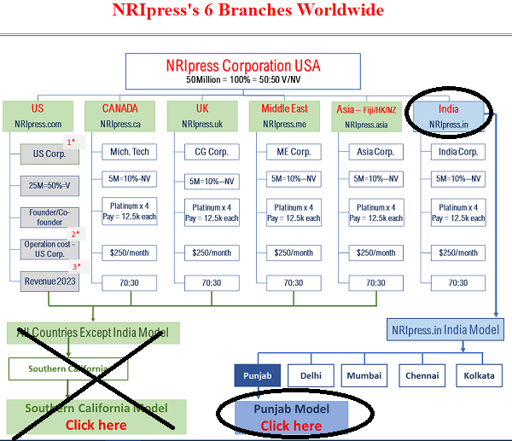

Click Here: Check NRIpress.in….. India Model……
-https://www.nriinternet.com/NRIpress.club/Master/Index.html-https://nriinternet.com/NRIpress.in/Index.html
 |  | NOTE: NRIpress.in may be continue as a division of NRIpress.com incorporation or independent company with contract people or charity or public company. This is the decision of board of directors and legal advisors.
4 | NRI Women Empowerment | a | Training 15 Media Executive | 15 girls as Media Executive in each Country | x |  |  |  | 60:40 after expenses
 |  | b | Other Programs |  | x
5 | NRI Senior Community centers |  | Planning in 2024, Model in LA |  | x |  |  | Keep set aside 25% of the  Revenue as admin- 60:40
*Platinum Member have special incentive if involve in some projects as a leader
**Platinum Member get special agreement as Leader and investor

TO COMPENSATE ABOVE SERVICES OUR REVENUE SHARING POLICY IS:
- REVENUE: Any revenue generate by you, 33,33% will go to NRIpress.com Inc, 33.33% to IT people and 33.33% to your account
- You will share 50:50 with other team member if you generate revenue with the help of that member
 |  |  | LA Model | California (3 times of LA)
1 | Revenue from NRIbusiness Directory with exclusive Membership: Websites: NRIaccountant.com , NRIrealtors.com and NRIdoctors….33.33% will go to NRIpress.com Inc, 33.33% to IT people and 33.33% to your account |  | Your Share
 | - In your area, we assume that we can add 5 business owners for exclusive club members on 20 websites | Revenue= Average $400 x 5 members x 20 websites= $40,000 /Year | Your Earning appx $ 13,000 per year | $ 40,000
 | - Sponsor News | $500 x 20 websites= $20,000 | Your Earning appx $ 3,300 per year | $ 10,000
2 | Revenue from Sponsor News to become NRIpress.club Members by you: |  | Your Share
 | - Bronze Members | - All/General NRIs x100mem x $100 | Your Earning appx $ 3,300 per year | $ 10,000
 | - Silver Members: | Associations: $250/year: Web Page, 2-3 photos/ Aricle …20 Association | Your Earning appx $ 3,300 per year | $ 10,000
 | - Gold Members: | All Businesses- $450/year: Web Page, 10-15 Photos and Aricles… | As per NRI business Directory | xx
 | - Diamond Members | Sponsors News/Club Members…. 5 members x $1000 | Your Earning appx $ 3,300 per year | $ 10,000
 | - Platinum Members | Sponsors of News/Co Founders .. 3 members x $ 5000 | Your Earning appx $ 5,000 per year | $ 15,000
3 | Revenue from Web sites Development: | Already set up. No advance $ to India….10 websites/yr x $1000 | Your Earning appx $ 3,300 per year | $ 10,000
4 | Selling Rights in North America, Europe, Asia @India | Each City $10,000 Average x 5 | ???? | ???
5 | Finder’s fees: | You will get 20% cash of total investment as finder fees or subject to mutual further agreement | ???? | ???
6 | If you like to involve in rights/franchise for your city or even other City/State or Country you bid. | 33% discount to you | ??? | ???

Starting July01, 2024 YOUR NAME’s designation will be as vice President, Los Angeles, California

Your duties will include:
- News, Video and press releases by covering the NRI events in surrounding areas.
- NRIpress.club activities include: To help Needy NRIs, to promote NRI Businesses, Encourage NRI Youths, Organize Annual Functions and seminars to honor the best and the brightest of our NRIs and help to set up NRIpress-Club in major cities of the world.
- YOU will also attend the meetings of NRIpress-club for further development and press coverages
- YOU shall also coordinate with our worldwide operation to update news and videos and functions
- All data of news/Video/photos and other related software and products shall be the property of NRIpress
- Press release must be done within 24-48 hours: This is general practice in news media and all the team members are anxious to make a press release ASAP.
- In 2024, we expect that any event finished, within hours photo or video shall be posted through email or other IT directions.
IN MANAGEMENT POSITIONS: You must be Diamond member by filling Application for 2024. Or also Diamond Members can add two Advertisements or sponsorship News or videos as club member. You might be one of our 100 diamond members worldwide as co-founders.

